**Department of Computer Science and Engineering**  
 **ADITYA COLLEGE OF ENGINEERING AND TECHNOLOGY**  
 Surampalem, Andhra Pradesh

**FREELANCEFINDER**

***Discovering Opportunities, Unlocking Potential***



**Submitted by**

[BOTSA GOWTHAMI] - [ 23MH1A05F1]

[GATTI SATYA SRINIVASA M NAGA MANIKANTA] - [23MH1A0589]

[KANOORI RAMBABU] - [23MH1A0597]

[VALLABHAPURAM] - [23MH1A0564]

**Submitted to**  
[Mr. Anji Babu]  
*Project Guide, Dept. of CSE*

**June 2025**

**ACKNOWLEDGEMENT**

We take immense pleasure in expressing our heartfelt gratitude to all those who contributed directly or indirectly to the successful completion of our internship project titled **“FreelanceFinder – Discovering Opportunities, Unlocking Potential.”**

First and foremost, we are sincerely thankful to our esteemed project guide, **[ANJAI BABU]**, for their continuous support, expert guidance, and valuable suggestions throughout the development of this project. Their insights and encouragement were crucial in transforming our ideas into a functional solution.

We extend our sincere thanks to the **Head of the Department, Department of Computer Science and Engineering**, and all faculty members of **Aditya College of Engineering and Technology**, for providing us with the platform, encouragement, and resources necessary to undertake this project.

Our heartfelt gratitude also goes to **FIVERR** for offering us the opportunity to work on this real-time, industry-relevant platform. Their mentorship and feedback played a pivotal role in shaping the quality and direction of our work.

We are especially thankful to our team members, whose collaboration, commitment, and enthusiasm helped us overcome challenges and meet our project goals:

* (Botsa Gowthami ),
* ( Gatti Satya Srinivasa M Naga Manikanta) ,
* (Kanoori Rambabu) ,
* ( Vallabhapuram Saisuhas ).

Lastly, we would like to thank our **parents, friends, and well-wishers** for their continuous encouragement, motivation, and moral support throughout this journey.

This project has helped us not only strengthen our technical abilities but also improve our teamwork, communication, and problem-solving skills. It has been a valuable learning experience, and we are proud of what we have achieved together.

**TABLE OF CONTENTS**

| **S. No.** | **Content** | **Page No.** |
| --- | --- | --- |
| 1. | **COVER PAGE** | 1 |
|  | **ACKNOWLEDGEMENT** | 2 |
| 3. | **TABLE OF CONTENTS** | 3 |

4. **INTRODUTION** 4–5

4.1 Project Overview

4.2 Purpose

5. **IDEACTION PHASE 6-7**

5.1 Problem Statement

5.2 Empathy Map Canvas

6. **REQUIREMENT ANALYSIS 8-11**

6.1 Customer Journey Map

6.2 Solution Requirement

6.3 Data Flow Diagram

7. **PROJECT DESIGN 1**2-16

7.1 Problem Solution Fit

7.2 Proposed Solution

7.3 Solution Architecture

8. **PROJECT PLANNING & SCHHEDULING** 17-18

8.1 Project Planning

9.  **FUNCTIONAL AND PERFORMING TESTING** 18-23

9.1 Performance Testing

10. **RESULT 23**

10. Output Screenshots

11. **ADVANTAGES & DISADVANTAGES 24**

12. **CONCLUSION 25**

13. **FUTURE SCOPE 26-27**

14.  **APPENDIX 28-32**

Source Code (if any)

Dataset Link

GitHub & Project Demo Link

**Freelancing Application MERN**

**INTRODUCTION**

FIVERR is a freelancing platform that connects clients with skilled freelancers. It offers an intuitive interface for project posting, bidding, and streamlined collaboration. With a dedicated admin team ensuring security and smooth communication, FIVERR aims to be the go-to platform for both clients and freelancers.

**4.1 Project Overview**

Welcome to FIVERR, a revolutionary freelancing platform that transforms the way clients connect with skilled freelancers. Our intuitive interface provides clients with the opportunity to post diverse projects, ranging from creative endeavours to technical tasks, while freelancers can seamlessly bid on these projects based on their expertise and capabilities.

At FIVERR, we prioritize efficiency and transparency in the freelancing process. Clients can review freelancer profiles, assess past work, and select the perfect candidate for their project. Once a freelancer is chosen, the client can easily communicate and collaborate with them within the platform, streamlining the entire workflow.

Our dedicated admin team ensures the integrity and security of every transaction. With stringent oversight, we guarantee the reliability and quality of the freelancers on our platform. The admin's role is not only to maintain the platform's integrity but also to facilitate smooth communication between clients and freelancers, ensuring a positive and productive working relationship.

Freelancers on FIVERR benefit from a straightforward project submission process. After completing the assigned project, freelancers can submit their work directly through the platform, offering clients a hassle-free experience. Clients have the opportunity to review the work and provide feedback, fostering a collaborative environment that values excellence.

Stay informed about the latest projects and industry trends with real-time updates and notifications. aims to be the go-to platform for clients seeking reliable freelancers and freelancers looking for exciting opportunities to showcase their skills.

Join FIVERR today and experience a new era of freelancing where your projects are efficiently managed, your skills are recognized, and collaborations flourish in a secure and dynamic environment.

**4.2 Purpose**

In today’s gig economy, the demand for flexible, project-based work is increasing. Freelancers are constantly searching for opportunities to showcase their skills, while clients are seeking qualified professionals to get tasks done efficiently. However, the freelancing ecosystem still faces key issues that hinder productivity and trust.

Many existing freelancing platforms suffer from:

* + **Overwhelming interfaces** that are difficult to navigate
  + **Lack of transparency** in freelancer credibility and reviews
  + **Inefficient communication** between clients and freelancers
  + **Delayed or insecure project delivery workflows**
  + **Limited admin control**, leading to trust and moderation issues

At the same time, many talented individuals-especially early-career freelancers—struggle to find reliable platforms that promote their work and facilitate growth. Likewise, clients often hesitate due to inconsistent quality or unreliable interactions.

**FIVERR (FreelanceFinder)** is developed to bridge this gap by offering:

* + A clean and easy-to-use interface for clients and freelancers
  + Project posting, bidding, chat, and submission features - all in one place
  + Admin moderation tools to maintain platform security and integrity
  + A system that promotes accountability, quality work, and collaboration

This project aims to simplify freelancing by building a platform that not only connects clients and freelancers but also enhances their working relationship through intuitive design, secure workflows, and transparency.

**IDEACTION PHASE**

**5.1 PROBLEM STATEMENT**

Finding the right freelancer or getting the right freelance job shouldn’t be a struggle — but for many, it still is. Clients often have a hard time identifying trustworthy, skilled professionals, while freelancers frequently face challenges showcasing their talent and getting hired for the right projects. Communication gaps, unclear processes, and security concerns make things even harder on both sides.

**FIVERR** was built to solve these problems by creating a platform where clients and freelancers can connect easily, work together smoothly, and build trust — all in one secure and supportive space.

**5.2 EMPATHY MAP CANVAS**

User Persona 1: Freelancer (e.g., a Web Developer or Graphic Design)

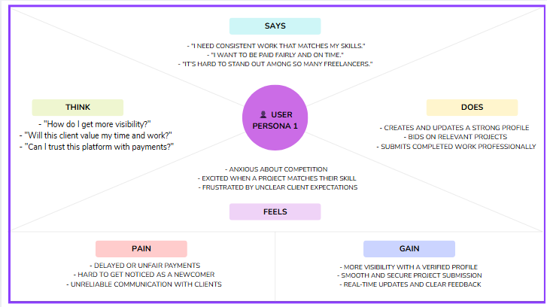

User Persona 2: Client ( e.g., Startup Founder, Small Business Owner)

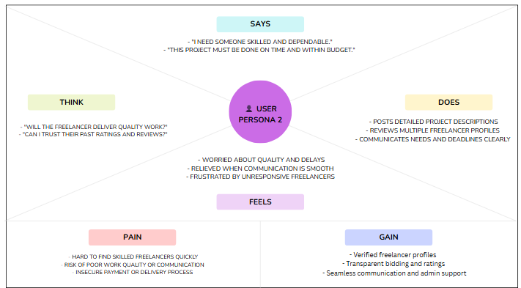

**REQUIREMENT ANALYSIS**

**3.2 Solution Requirements**

The primary objective of **FreelanceFinder – Discovering Opportunities, Unlocking Potential** is to design and develop a secure, responsive, and user-friendly full-stack freelancing platform that facilitates seamless collaboration between clients and freelancers.

**Specific objectives of the project include:**

* **Develop a clean and intuitive user interface**  
  To enable users (clients and freelancers) to easily navigate, explore, and interact with the platform on any device.
* **Implement secure authentication and role-based access**  
  To ensure safe login/signup with appropriate permissions for clients, freelancers, and admin.
* **Enable project posting and bidding system**  
  To allow clients to post projects with requirements and freelancers to submit proposals confidently.
* **Create a dedicated freelancer portfolio module**  
  To let freelancers showcase skills, past work, ratings, and gain client trust.
* **Facilitate real-time chat and communication**  
  To improve collaboration and reduce delays between project stakeholders.
* **Design a project submission and feedback workflow**  
  To streamline the handover, review, and approval process between clients and freelancers.
* **Incorporate admin monitoring and control features**  
  To maintain platform integrity, manage disputes, and ensure quality control.
* **Use scalable full-stack architecture and modern technologies**  
  To apply React.js, Node.js, Express.js, and MongoDB efficiently in a real-world scenario.
* **Promote transparency and reliability throughout the system**  
  To build trust between users and create a professional, feedback-oriented environment.

By meeting these objectives, the platform addresses real-world freelancing pain points while also serving as a comprehensive technical learning experience for the development team.

**3.3 Technology Stack**

To build a robust, scalable, and efficient freelancing platform, our team employed a modern full-stack development approach. The choice of technologies was driven by real-world industry standards, community support, and flexibility in development.

Below are the core technologies used in developing **FreelanceFinder – Discovering Opportunities, Unlocking Potential**:

**Frontend Technologies**

* **HTML5** – For semantic structuring of the website content
* **CSS3** – For designing responsive and visually engaging layouts
* **JavaScript (ES6+)** – To add interactivity and control DOM behavior
* **React.js** – To build a dynamic Single Page Application (SPA) using reusable components
* **Bootstrap** – For responsive UI design and layout consistency
* **Material UI** – For modern, customizable, and prebuilt UI components

**Backend Technologies**

* **Node.js** – JavaScript runtime environment used for executing server-side logic
* **Express.js** – Backend framework for handling routing, middleware, and RESTful API creation

**Database**

* **MongoDB** – A NoSQL database used for storing user accounts, project listings, bids, chats, and submissions
* **Mongoose** – ODM library used for modeling application data and schema validation

**Security & Communication**

* **JWT (JSON Web Token)** – For secure user authentication and session handling
* **bcrypt.js** – For hashing and securing user passwords
* **Axios** – To handle HTTP requests between the frontend and backend

**Development & Testing Tools**

* **Postman** – For testing API endpoints and request-response flows
* **Git & GitHub** – For version control and collaborative development
* **Visual Studio Code (VS Code)** – The primary code editor used for writing, debugging, and managing the project

Together, these technologies provided the foundation for building a fully functional, real-time, and secure freelancing platform, reflecting both best practices in web development and practical implementation of full-stack principles.

**3.4SYSTEM ARCHITECTURE & FLOW DIAGRAM**

The system architecture of **FreelanceFinder** follows a **modular client-server model** using full-stack web technologies. It is designed to provide secure, real-time interaction between users (clients and freelancers), backend services, and a cloud-based database.

**Architecture Layers**

* **User Interface (Frontend)**  
  Built using **React.js**, **HTML**, **CSS**, **Bootstrap**, and **Material UI** to provide a dynamic, responsive, and visually consistent experience across devices.
* **Application Logic (Backend)**  
  Developed with **Node.js** and **Express.js** to manage routes, business logic, user roles, and RESTful API handling.
* **Database Layer**  
  **MongoDB** serves as the NoSQL backend database to store structured and semi-structured data like:
* User profiles
* Projects and bids
* Messages and chat logs
* Submission history and feedback
* **API Communication**  
  RESTful APIs built with Express.js handle communication between frontend and backend. **Axios** is used to send HTTP requests securely and asynchronously.
* **Authentication & Security**
  + **JWT (JSON Web Token)** ensures session-based authentication
  + **bcrypt.js** is used for password hashing
  + Access levels are managed for freelancers, clients, and admins

FLOW DIAGRAM

This architecture allows real-time communication, easy scalability, and role-based access. It ensures that clients, freelancers, and admins can seamlessly interact with the system while maintaining security and performance.

**4. PROJECT DESIGN**

The core functionality of **FreelanceFinder** revolves around making freelancing accessible, efficient, and transparent. Each module was designed to ensure smooth collaboration between clients and freelancers, supported by secure admin oversight.

**4.1Problem Solution Fit**

**1. User Authentication Module**

* Secure login/signup for clients, freelancers, and admins
* Password hashing using **bcrypt.js**
* Session management with **JWT** tokens
* Role-based access control

**2. Project Posting & Bidding Module**

* Clients can post projects with detailed descriptions and requirements
* Freelancers can browse projects, view budgets and deadlines
* Proposal submission with optional attachments or portfolio samples
* Bidding logic to support competitive freelancer selection

**3. Freelancer Profile & Portfolio Module**

* Profile editing with bio, skills, experience, and reviews
* Portfolio uploads to showcase previous work
* Rating system based on client feedback

**4. Real-time Communication Module**

* Integrated chat interface for each project
* Instant messaging between freelancers and clients
* Supports follow-ups, file sharing, and clarification

**5. Project Submission & Feedback**

* Freelancers can submit completed work through the platform
* Clients can review, accept, or request revisions
* Feedback and ratings provided after delivery

**6. Admin Dashboard**

* User account monitoring and approval
* Access to reported content and communication logs
* Authority to resolve disputes and maintain platform standards

**7. Notification System**

* Real-time alerts for new messages, project updates, and bids
* Email or in-app notifications for major actions

**8. Responsive Design & Cross-Browser Compatibility**

* UI developed using **Bootstrap** and **Material UI**
* Fully responsive layout across desktop, tablet, and mobile devices

**9. API Integration Module**

* Frontend-backend interaction via **Axios + RESTful APIs**
* Modular design for scalability and easier maintenance

**10. MongoDB Data Management**

* Efficient data retrieval and updates using **Mongoose** models
* Collections for users, projects, proposals, messages, and feedback
* Validation and indexing for performance

These modules collectively ensure that **FreelanceFinder** offers a complete, real-world solution for modern freelancing workflows, combining simplicity with security and professional-grade features.

**4.2 Proposed Solution**

The development of **FreelanceFinder** followed a modular, iterative approach, where each feature was implemented, tested, and integrated into the overall system. This ensured smooth development, efficient debugging, and clarity in team collaboration.

* **Frontend Implementation**
* Built using **React.js** for dynamic rendering and SPA behavior
* Components created for navigation, login/register, dashboard, project posting, and chat
* UI styling handled using **Bootstrap** and **Material UI**
* **Axios** used to fetch/post data asynchronously via REST APIs
* React Router used for navigation between views
* **Backend Implementation**
* Developed using **Node.js** and **Express.js** to manage server logic
* RESTful API routes were created for:
  + User authentication
  + Project creation and retrieval
  + Proposal submissions
  + Chat and message handling
* Middleware used for authentication, input validation, and error handling
* **Database Implementation**
* **MongoDB** used for storing structured collections like:
  + Users (clients/freelancers/admins)
  + Projects and proposals
  + Chat messages and feedback
* **Mongoose** schemas defined to enforce data structure and validation rules
* **Authentication & Authorization**
* Users authenticated via **JWT** tokens
* Passwords hashed using **bcrypt.js**
* Role-based access ensures only authorized users access certain actions (e.g., only clients can post projects)
* **Project and Proposal Workflow**
* Clients post new projects with title, description, deadline, and budget
* Freelancers browse open projects and submit proposals with descriptions and attached work
* Clients review and assign freelancers to their projects
* **Chat & Communication**
* Once assigned, a private chat is initiated between the freelancer and client
* Messages are stored and updated in real time
* Files can be shared through this chat interface
* **Project Delivery & Feedback**
* Freelancers submit work via a dedicated form
* Clients review submissions and can:
  + Approve the work
  + Request revisions
  + Leave feedback and a star rating
* **Testing & Debugging**
* Used **Postman** to test all backend APIs
* React Dev Tools and browser console used for frontend debugging
* GitHub version control managed team contributions and resolved merge conflicts

This layered implementation ensures that all modules — from login to delivery — are interconnected, secure, and optimized for a real-world freelancing experience.

**4.3 Solution Architecture**

**Application flow:**

**Freelancer Responsibilities:**

• Project Submission: Freelancers are responsible for submitting completed and high-quality work for the assigned projects through the platform.

• Compliance: Ensure that the submitted work adheres to client requirements, industry standards, and any specific guidelines outlined by the platform.

• Effective Communication: Actively engage in communication with clients, promptly responding to messages, asking clarifying questions, and providing updates on the project progress.

• Time Management: Manage time effectively to meet project deadlines and deliver work in a timely manner.

• Professionalism: Conduct oneself professionally by maintaining a respectful and cooperative attitude with clients and fellow freelancers.

• Quality Assurance: Deliver work that is accurate, well-executed, and free from errors to maintain client satisfaction.

**Client Responsibilities:**

• Clear Project Description: Provide a detailed and comprehensive project description, including deliverables, desired outcomes, and any specific requirements.

• Timely Communication: Respond promptly to freelancer inquiries, providing necessary information and feedback in a timely manner.

• Payment Obligations: Fulfill the agreed-upon payment terms promptly and fairly upon satisfactory completion of the project.

• Feedback and Evaluation: Provide constructive feedback and evaluate the freelancer's performance, helping them improve and providing valuable insights.

**Admin Responsibilities:**

* Data Oversight: As an admin, one of your key responsibilities is to monitor and ensure the integrity and security of all data on the platform
* Policy Enforcement: Admins play a crucial role in enforcing platform policies, guidelines, and ethical standards.
* Conflict Resolution: In the event of disputes or issues within the community, it is the admin's responsibility to address them promptly and impartially
* User Support and Communication: Admins should provide support and guidance to users on the platform
* Platform Maintenance and Improvement: Admins are responsible for the overall maintenance and improvement of the research platform.

**CHALLENGES FACED**

Throughout the development of **FreelanceFinder**, our team encountered various technical and collaborative challenges. Overcoming these issues provided valuable learning experiences and enhanced our problem-solving and teamwork abilities.

**1. Technology Integration**

Integrating frontend (React.js) with backend (Node.js + Express) and connecting to MongoDB via REST APIs required careful planning and coordination. Achieving smooth communication between all layers took significant effort.

**2. State Management**

Handling component states in React, especially during project bidding and real-time chat updates, was initially complex. We overcame this by leveraging React hooks and lifting states appropriately across components.

**3. Database Schema Design**

Designing MongoDB schemas to support users with different roles (client, freelancer, admin) and linking projects, bids, messages, and feedback efficiently involved several iterations for optimization.

**4. Role-based Access Control**

Implementing clear boundaries for client, freelancer, and admin access required strict logic in backend routes and consistent handling on the frontend to prevent unauthorized operations.

**5. Real-time Features**

Creating a chat system that felt real-time, while maintaining data integrity, was a technically demanding task. It required structured message models, controlled updates, and smooth frontend rendering.

**6. Responsive UI Design**

Ensuring a consistent and user-friendly experience across desktop, tablet, and mobile devices challenged us to dive deep into **Bootstrap** grid systems and custom media queries.

**7. Security & Authentication**

Learning how to securely hash passwords with **bcrypt.js**, manage user sessions with **JWT**, and protect routes against unauthorized access required thorough research and practice.

**8. Team Collaboration & Time Management**

Coordinating code contributions, handling merge conflicts, and balancing project tasks with academic responsibilities were challenges we managed through regular meetings and Git/GitHub collaboration.

These obstacles, though difficult at times, significantly strengthened our technical foundation and taught us to think like professional developers.

**5. PROJECT PLANNING & SCHEDULING**

**Milestone 1: Project setup and configuration.**

* **Folder setup:**

Now, firstly create the folders for frontend and backend to write the respective code and install the essential libraries.

* Client folders.
* Server folders

* **Installation of required tools:**

1. Open the frontend folder to install necessary tools

For frontend, we use:

* React
* Bootstrap
* Material UI
* Axios
* react-bootstrap

2. Open the backend folder to install necessary tools

For backend, we use:

* Express Js
* Node JS
* MongoDB
* Mongoose
* Cors
* Bcrypt

After the installation of all the libraries, the package.json files for the frontend looks like the one mentioned below.

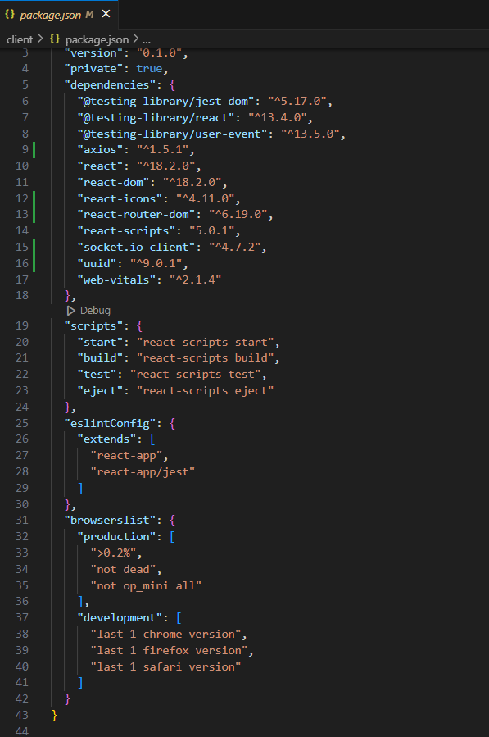

After the installation of all the libraries, the package.json files for the backend looks like the one mentioned below.

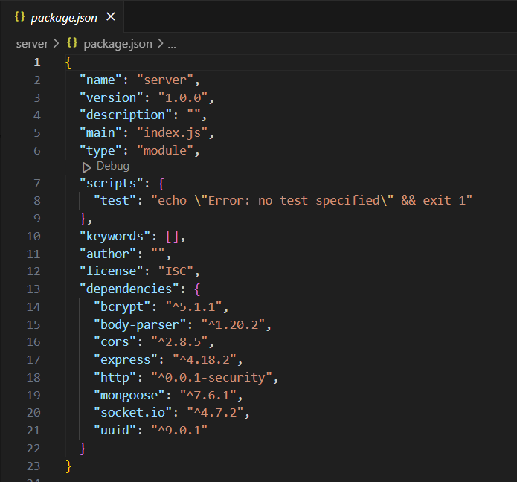

**Milestone 2: Backend Development**

**1. Project Setup:**

* Create a project directory and initialize it using npm init.
* Install required dependencies like Express.js, Mongoose, body-parser, and cors.

**2. Database Configuration:**

* Set up a MongoDB database (locally or using a cloud service like MongoDB Atlas).
* Create collections for:
* Users (storing user information, account type)
* Projects (project details, budget, skills required)
* Applications (freelancer proposals, rate, portfolio link)
* Chat (communication history for each project)
* Freelancer (extended user details with skills, experience, ratings)

**3. Express.js Server:**

* Create an Express.js server to handle HTTP requests and API endpoints.
* Configure body-parser to parse request bodies and cors for cross-origin requests.

**4. API Routes:**

* Define separate route files for user management, project listing, application handling, chat functionality, and freelancer profiles.
* Implement route handlers using Express.js to interact with the database:
* User routes: registration, login, profile management.
* Project routes: project creation, listing, details retrieval.
* Application routes: submit proposals, view applications.
* Chat routes: send and receive messages within projects.
* Freelancer routes: view and update profiles, showcase skills.

**5. Data Models:**

* Define Mongoose schemas for each data entity:
* User schema
* Project schema
* Application schema
* Chat schema
* Freelancer schema (extends User schema with skills, experience)
* Create Mongoose models to interact with the MongoDB database.
* Implement CRUD operations for each model to manage data.

**6. User Authentication:**

* Implement user authentication using JWT or session-based methods.
* Create routes and middleware for user registration, login, and logout.
* Use authentication middleware to protect routes requiring user authorization (e.g., applying for projects).

**7. Project Management:**

* Allow clients to post projects with details and budget.
* Enable freelancers to browse projects, search by skills, and submit proposals.
* Implement a system for clients to review applications and choose freelancers.

**8. Secure Communication & Collaboration:**

* Integrate a secure chat system within projects for communication between clients and freelancers.
* Allow file attachments and feedback exchange to facilitate collaboration.

**9. Admin Panel (Optional):**

* Implement an admin panel with functionalities like:
* Managing users
* Monitoring project updates and applications
* Accessing transaction history

Reference video: <https://drive.google.com/file/d/1zrOMSp6svjH1tRcul3b442XVPNyKTSp4/view?usp=sharing>

**Milestone 3: Database development**

* Set up a MongoDB database either locally or using a cloud-based MongoDB service like MongoDB Atlas.
* Create a database and define the necessary collections for users, freelancer, projects, chats, and applications.
* Connect the database to the server with the code provided below

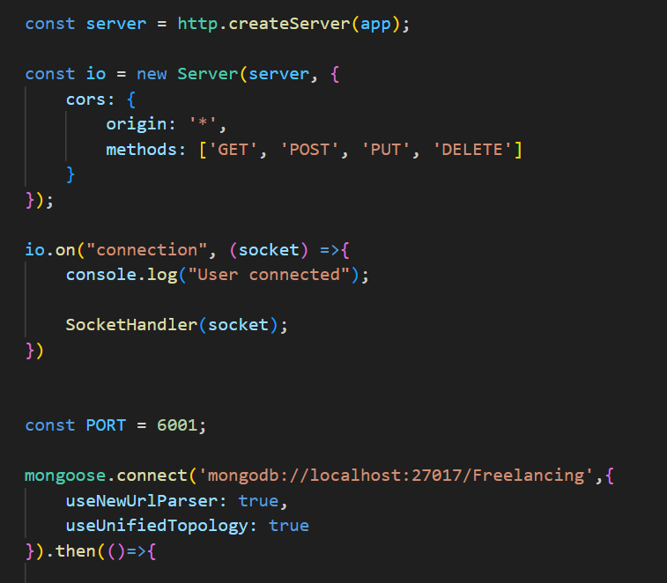

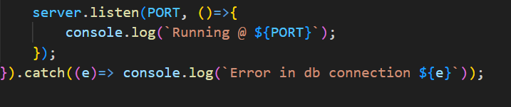

The Schemas for the database are given below

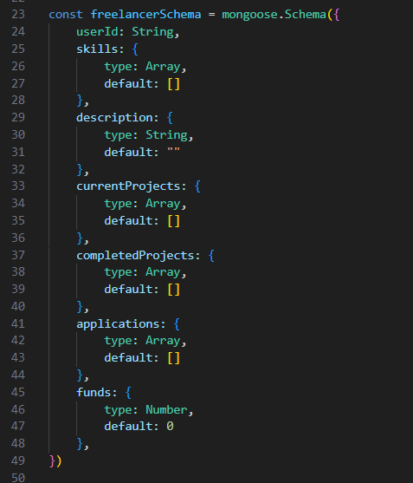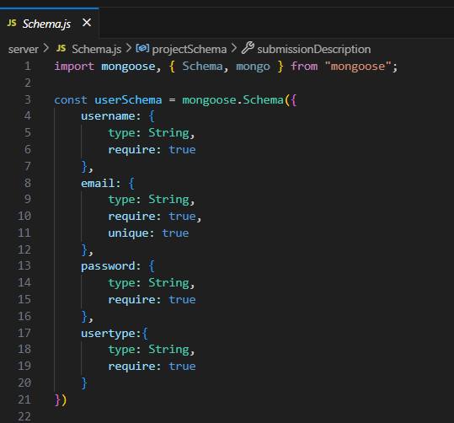

**Milestone 4: Frontend development**

**1. Setting the Stage:**

The SB Works frontend thrives on React.js. To get started, we'll:

* Create the initial React application structure.
* Install essential libraries for enhanced functionality.
* Organize project files for a smooth development experience.
* This solid foundation ensures an efficient workflow as we bring the SB Works interface to life.

**2. Crafting the User Experience:**

Next, we'll focus on the user interface (UI). This involves:

* Designing reusable UI components like buttons, forms, and project cards.
* Defining the layout and styling for a visually appealing and consistent interface.
* Implementing navigation elements for intuitive movement between features.
* These steps will create a user-friendly experience for both freelancers and clients.

**3. Bridging the Gap:**

The final stage connects the visual interface with the backend data. We'll:

* Integrate the frontend with SB Works' API endpoints.
* Implement data binding to ensure dynamic updates between user interactions and the displayed information.

This completes the frontend development, bringing the SB Works platform to life for users.

**7. RESULTS**

**7.1 OUTPUT SCREENSHOTS**



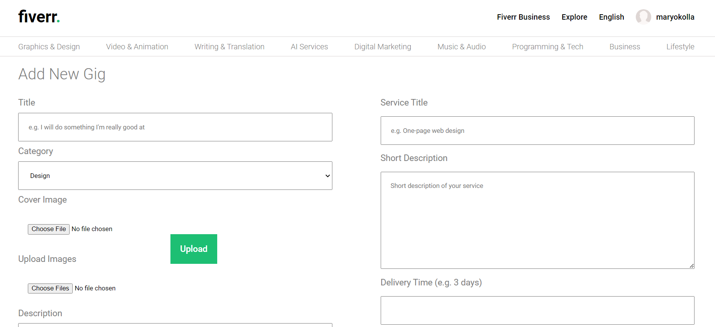

**8. ADVANTAGES & DISADVANTAGES**

**ADVANTAGES**

1. **User-Friendly Interface**  
   Easy for both clients and freelancers to navigate, post, and bid on projects.
2. **Verified Profiles**  
   Builds trust by allowing clients to assess freelancers based on past work and ratings.
3. **Streamlined Communication**  
   In-built chat and update system simplifies collaboration between both parties.
4. **Admin Oversight**  
   Ensures security, fairness, and smooth resolution of disputes or misunderstandings.
5. **Secure Payment System**  
   Reliable and transparent transaction handling increases user confidence.
6. **Real-Time Updates**  
   Keeps users informed about project status, messages, and new opportunities.
7. **Wide Project Range**  
   Supports various domains — from creative to technical — increasing user base diversity.

**DISADVANTAGES**

1. **Platform Dependence**  
   Users may rely entirely on SB Works, limiting opportunities outside the platform.
2. **High Competition**  
   Freelancers may struggle to stand out, especially newcomers without ratings.
3. **Admin Bottleneck**  
   Heavy admin involvement might slow down decision-making or conflict resolution.
4. **Learning Curve for New Users**  
   Clients unfamiliar with freelancing platforms may take time to use it effectively.
5. **Possible Fee Structure**  
   Platform service fees (if applied) might reduce freelancers' earnings or client budgets.
6. **Scalability Risks**  
   As the user base grows, maintaining quality control and support responsiveness may become challenging.

**FUTURE SCOPE**

As freelancing continues to evolve and digital marketplaces expand, there are several exciting possibilities for enhancing and scaling **FreelanceFinder** in future versions. The current platform lays a solid foundation that can be built upon with advanced features and integrations.

**1. Payment Gateway Integration**

Adding secure payment gateways such as Razorpay, Stripe, or PayPal will enable clients to make real-time payments directly through the platform, completing the project cycle within the system.

**2. AI-Based Project Recommendations**

Implementing AI and machine learning models can help in recommending projects to freelancers and suggesting the most suitable candidates to clients based on skill match, previous reviews, and bidding history.

**3. Mobile Application Development**

Building a mobile version using React Native or Flutter can significantly improve accessibility, allowing users to manage bids, projects, and chats on the go.

**4. Analytics and Insights Dashboard**

Both clients and freelancers can benefit from dashboards showing statistics like earnings, project status, response time, and performance history to make better decisions.

**5. Multilingual and Multi-Currency Support**

To reach a global audience, the platform can be enhanced to support multiple languages and currencies, opening doors to international freelancers and clients.

**6. Referral & Loyalty Programs**

Introducing a rewards system can encourage platform engagement. Freelancers can earn badges or bonuses, and users can refer others for benefits.

**7. Dispute Resolution & Escrow System**

Implementing an automated dispute handling process along with an escrow-based payment model can increase trust and ensure fairness in transactions.

**8. Chatbot for Quick Support**

An AI-based chatbot can be added for resolving common queries, guiding new users, and supporting issue escalation automatically.

**9. Milestone-Based Project Management**

Adding milestones, progress tracking, and deadline-based workflows will help in managing large projects more effectively and transparently.

By integrating these features, **FreelanceFinder** can evolve into a powerful, globally scalable freelancing ecosystem that provides both technical value and a great user experience.

**CONCLUSION**

The successful completion of **FreelanceFinder – Discovering Opportunities, Unlocking Potential** marks a significant milestone in our academic and professional journey. This full-stack web application was envisioned as a solution to the existing gaps in freelancing platforms, particularly in terms of usability, communication, and project transparency.

By integrating modern technologies such as **React.js**, **Node.js**, **Express.js**, and **MongoDB**, we developed a secure and dynamic platform where:

* Clients can seamlessly post and manage projects
* Freelancers can showcase their skills and bid competitively
* Admins can ensure reliability and system integrity

The platform facilitates real-time chat, efficient bid tracking, streamlined project delivery, and client feedback — all within a responsive and user-friendly environment.

**Key Takeaways:**

* We applied full-stack development principles to a real-world problem.
* We learned how to build scalable, secure RESTful APIs.
* We gained hands-on experience with authentication, frontend routing, and database modeling.
* We improved our collaboration, debugging, and deployment skills.

Beyond technical growth, this project helped us develop essential **soft skills** like:

* Project planning and task distribution
* Version control collaboration using Git/GitHub
* Effective communication and conflict resolution within a team

In conclusion, **FreelanceFinder** is more than just a project, it is a complete product cycle experience. It demonstrates our readiness to solve real-world problems using full-stack development, and it opens the door for future enhancements that could bring this platform closer to commercial-grade freelancing tools.

**11. APPENDIX**

**Source Code**

**“**

<!DOCTYPE html>

<html lang="en">

<head>

<meta charset="UTF-8" />

<meta name="viewport" content="width=device-width, initial-scale=1.0" />

<link

href="https://fonts.googleapis.com/css2?family=Roboto:ital,wght@0,100;0,300;0,400;0,500;0,700;0,900;1,100;1,300;1,400;1,500;1,700;1,900&display=swap"

rel="stylesheet"

/>

<link

href="https://fonts.googleapis.com/css2?family=Montserrat:ital,wght@0,100;0,200;0,300;0,400;0,500;0,600;0,700;0,800;0,900;1,100;1,200;1,300;1,400;1,500;1,600;1,700;1,800;1,900&display=swap"

rel="stylesheet"

/>

<style>

* {

padding: 0;

margin: 0px;

font-family: "Roboto", sans-serif;

}

</style>

<title>Freelance App</title>

</head>

<body>

<div id="root"></div>

<script type="module" src="/src/main.jsx"></script>

</body>

</html> “

Package.json

{

"name": "freelance-app",

"private": true,

"version": "0.0.0",

"type": "module",

"scripts": {

"dev": "vite",

"build": "vite build",

"preview": "vite preview"

},

"dependencies": {

"@stripe/react-stripe-js": "^1.16.4",

"@stripe/stripe-js": "^1.46.0",

"@tanstack/react-query": "^4.29.5",

"axios": "^1.3.3",

"infinite-react-carousel": "^1.2.11",

"moment": "^2.29.4",

"react": "^18.2.0",

"react-dom": "^18.2.0",

"react-router-dom": "^6.8.0",

"sass": "^1.58.0"

},

"devDependencies": {

"@types/react": "^18.0.26",

"@types/react-dom": "^18.0.9",

"@vitejs/plugin-react": "^3.0.0",

"eslint": "^8.33.0",

"eslint-plugin-react": "^7.32.2",

"vite": "^4.0.0"

}

}

**Client (Html)**

<!DOCTYPE html>

<html lang="en">

<head>

<meta charset="UTF-8" />

<meta name="viewport" content="width=device-width, initial-scale=1.0" />

<link

href="https://fonts.googleapis.com/css2?family=Roboto:ital,wght@0,100;0,300;0,400;0,500;0,700;0,900;1,100;1,300;1,400;1,500;1,700;1,900&display=swap"

rel="stylesheet"

/>

<link

href="https://fonts.googleapis.com/css2?family=Montserrat:ital,wght@0,100;0,200;0,300;0,400;0,500;0,600;0,700;0,800;0,900;1,100;1,200;1,300;1,400;1,500;1,600;1,700;1,800;1,900&display=swap"

rel="stylesheet"

/>

<style>

* {

padding: 0;

margin: 0px;

font-family: "Roboto", sans-serif;

}

</style>

<title>Freelance App</title>

</head>

<body>

<div id="root"></div>

<script type="module" src="/src/main.jsx"></script>

</body>

</html>

**GITHUB LINK & PROJECT DEMO LINK**

https://github.com/23MH1A05F1/FreelanceFinder.git

Setup

* Clone the project: https://github.com/23MH1A05F1/FreelanceFinder.git
* Change directory into both client and server directories separately: cd /client && cd /server
* Install the required dependencies for both client and server: npm install
* Setup mongodb database and add url to .env file configuration
* Run both the applications simultaneously: client npm run dev and server npm run dev
* View the application on the browser using http://localhost:5173

**REFERENCES**

The following online resources, tools, and platforms were extensively used during the research, development, testing, and documentation of this project:

1. **MDN Web Docs (Mozilla Developer Network)**  
   <https://developer.mozilla.org>  
   For foundational understanding of HTML, CSS, JavaScript, and DOM manipulation.
2. **React.js Official Documentation**  
   <https://react.dev>  
   For learning about component structure, hooks, state management, and routing.
3. **Node.js & Express.js Documentation**  
   <https://nodejs.org/en/docs>  
   <https://expressjs.com>  
   For backend logic, server configuration, and RESTful API development.
4. **MongoDB Documentation**  
   <https://www.mongodb.com/docs>  
   For database schema design, CRUD operations, and Mongoose integration.
5. **Bootstrap Documentation**  
   <https://getbootstrap.com>  
   Used for building responsive layouts and UI components.
6. **Material UI Documentation**  
   <https://mui.com>  
   For implementing polished, accessible, and consistent design elements.
7. **Postman**  
   <https://www.postman.com>  
   Used for testing API endpoints and analyzing backend responses.
8. **GitHub**  
   <https://github.com>  
   For version control and collaborative development.
9. **YouTube Channels**
   * Traversy Media
   * The Net Ninja
   * Programming with Mosh  
     For practical tutorials, full-stack project walkthroughs, and advanced tips.
10. **GeeksforGeeks**  
    <https://www.geeksforgeeks.org>  
    Used for reference on algorithms, backend logic, and JavaScript topics.
11. **ChatGPT by OpenAI**  
    <https://chat.openai.com>  
    Used for brainstorming, error debugging, writing explanations, and improving documentation clarity.